Data Driven Testing in Cucumber, there are 3 methods

1. Simple Data Driven—without Examples keyword
2. With Examples + Scenario Outline
3. Using Tables

**First Process**: Simple Data Driven—Without Examples keyword

Go to the feature file and hardcode username and password as shown below

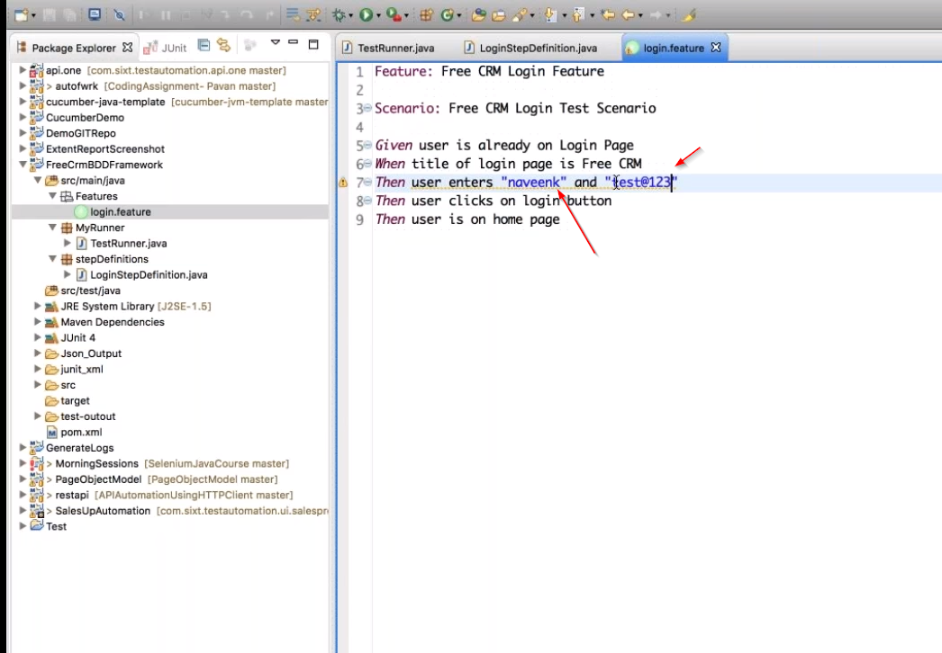

Step Definitions file

Replace username and password with regular expressions shown in below screen

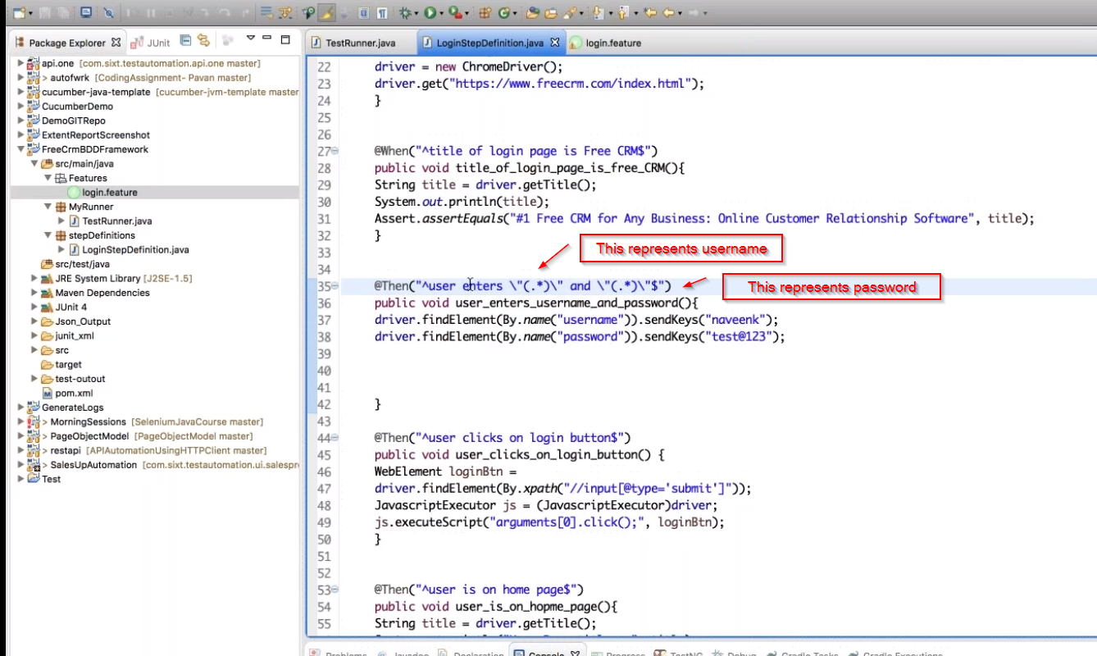

Make below changes

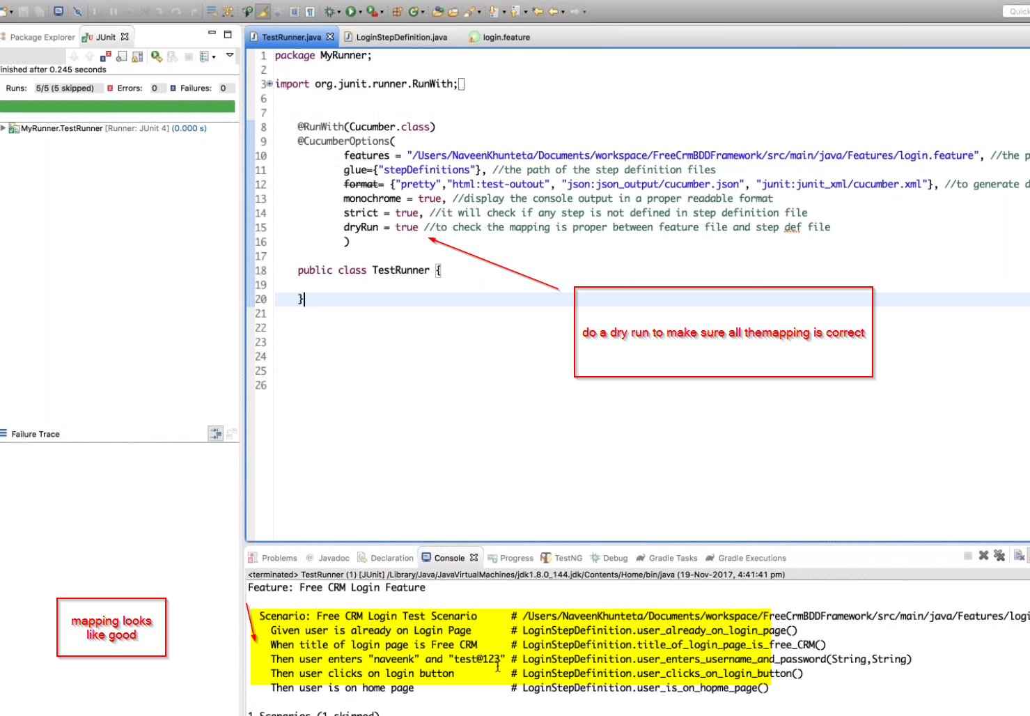

**Second Process**: With Examples keyword

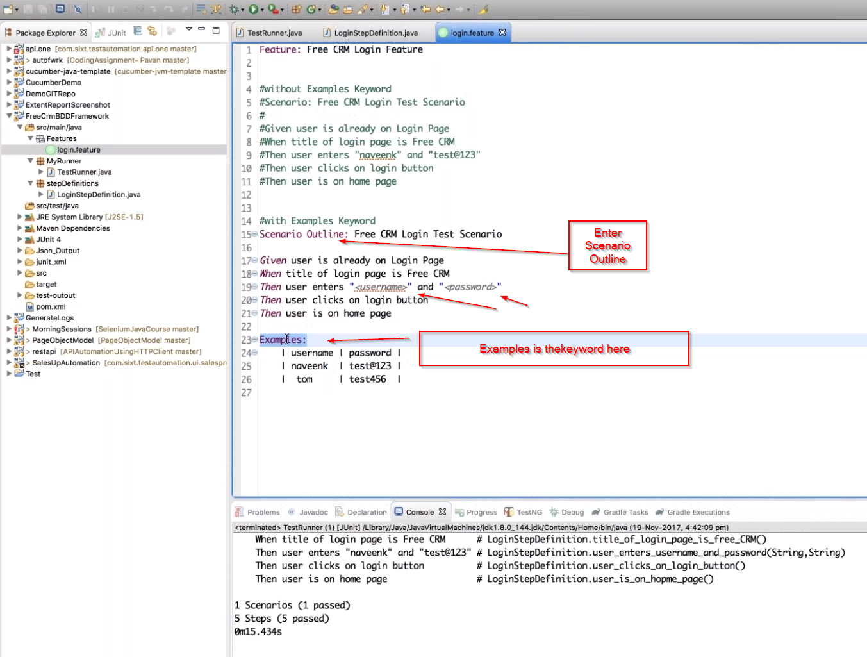

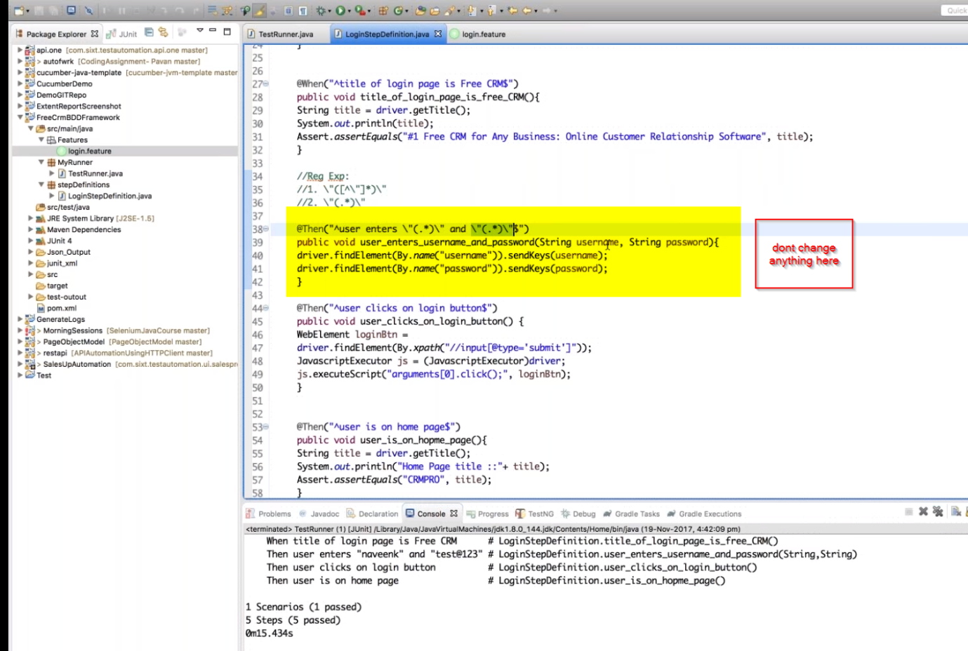

**Third Method:**

**Create list object for data driven testing**

